Downloading and installing XAMPP Virtual Web Server

This document shows you know to download and install the XAMPP virtual web server on your local machine. A number of different key issues may arise during the install process, each of these will be explained. This is a guide only and screens may vary depending on your operating system and the version you select

**What is XAMPP?**

XAMPP is a virtual web server. It contains MySQL database, PHP language extension for apache, and Apache web server ready to use.

All of these come preconfigured with details default configuration details. All you need to do is turn the server on, and you will be able to use all of the software.

**[Step 1] Go to website**

First we need to download the XAMPP software. Open a web browser a head to <https://www.apachefriends.org/index.html>

Select what ever version is applicable to your operating system.

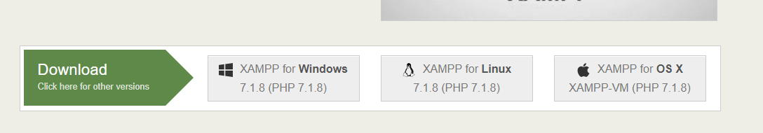

**[Step 2] Download** The XAMPP installer for windows will download. Once it has finished the download, run the installer on your computer. Find in the download folder in Windows and double click on file to start install.

A little warning message may show up telling you that the account you are using may not have

enough privileges, this is ok.

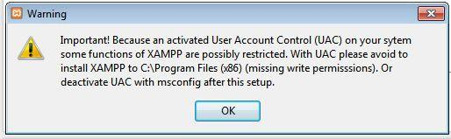

Begin the setup process by clicking next.

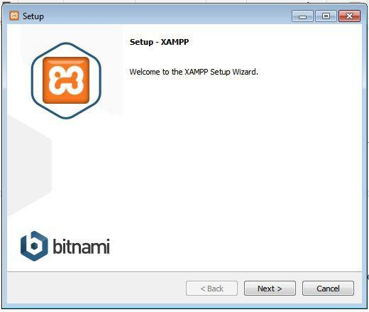

The installer will then ask you where it should install the XAMPP server. The default locations are ok, so you can just click next.

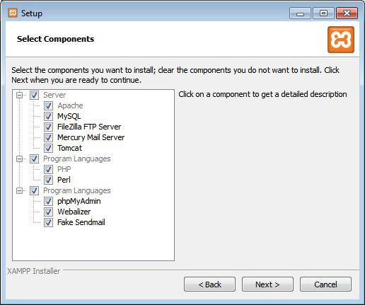

The installer will ask you where to install XAMPP, the default directory is fine.

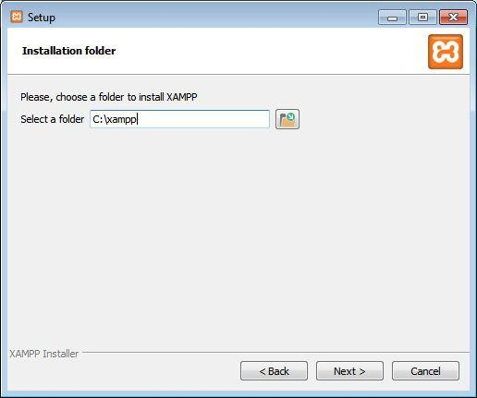

An option is available to learn more about binami, a service for quickly installing web applications on your xampp server. We will not need this, so untick the box.



You are now ready to begin the installation process, click next to continue

. 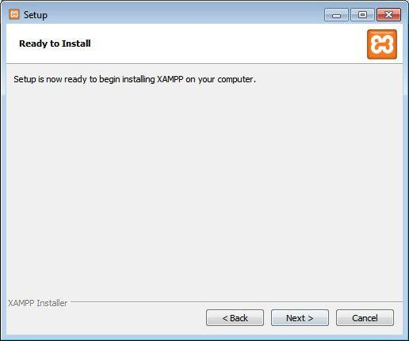

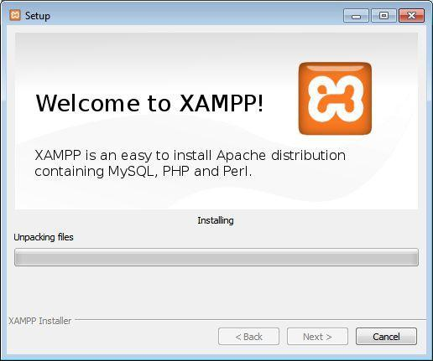

The installer will begin the installation process, this may take some time as the file size is quite big.

After the installation has completed you will be given the option to launch the console. Tick the box and then select Finish.

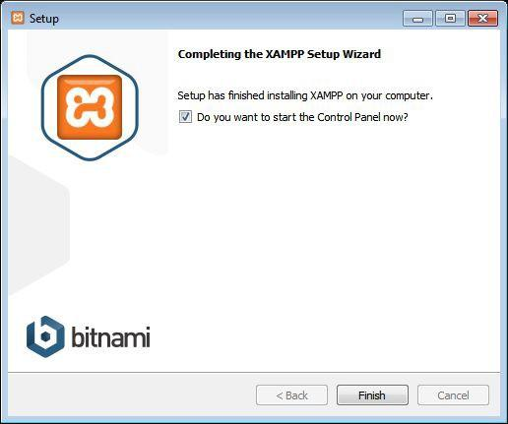

**[Step 3] ­ Running the console**

After we have installed XAMPP the next thing we need to do is open the command console for

XAMPP.

By going to the start menu on the bottom left corner of your screen, then to Program Files and then to the XAMPP folder you will see an icon for the “XAMPP Control Panel”. Click this, and you will see the command console shown below.

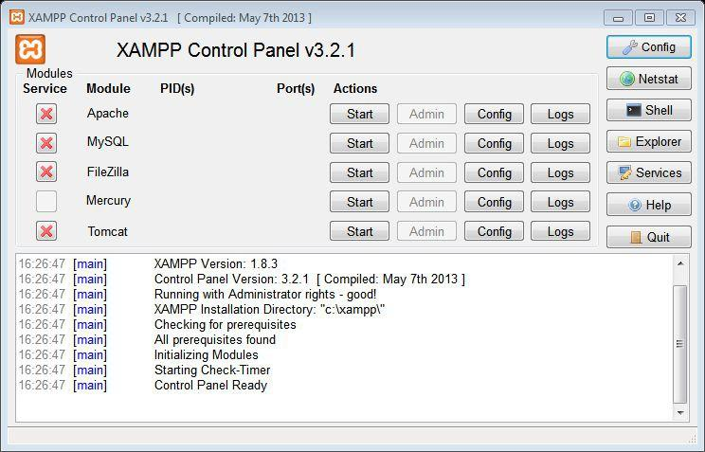

**[Step 4]** ­ **Starting Services**

Now that you have installed XAMPP the next thing we need to do is to start the services. The services that we will need to run are

­ MySQL ­ The database that we will use

­ Apache ­ The web server that we will use

Remember that for XAMPP to run correctly, a number of different pieces of software all need to run together without any flaws, all at the same time. One of the tools that are running, e.g. Apache may have a port blocked and prevent the process from running. Be prepared to do a little bit of problem solving if this happens.

MySQL database by default runs on port 3306. If you notice that the database will not run correctly, you can change the port it is running on to a different port, e.g. 3307 and you will be surprised how it will suddenly solve the issue.

The same can be said for the Apache web server. By default web servers run on port 80. If your instance of apache is not running correctly you may want to try a different port, e.g. port 81. This can quickly and easily solve your issues.

First click the start button beside Apache



Second click the start button beside MySQL



Hopefully these will run without issues. Your firewall may ask to you allow Apache or MySQL. If this happens, allow your firewall to allow these programs (shown below).

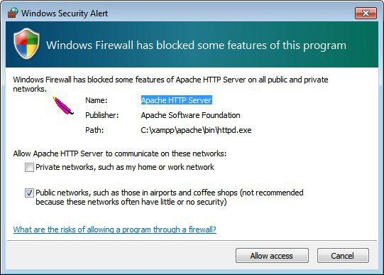

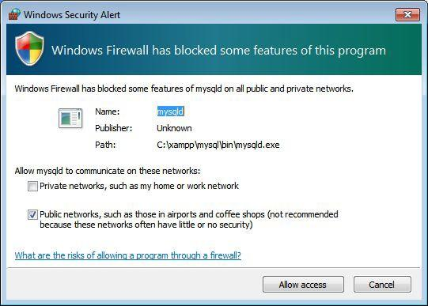

If everything goes to plan, you will see two green bars beside the services that are currently running on your local server.

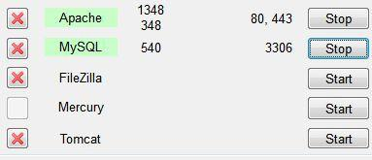

**[Step 5] ­ Open localhost**

The next step is to view your web server in action through the web browser. To do this, open a web browser e.g. Chrome and type the word localhost into your URL bar. If everything has gone to plan, you should see the web page for XAMPP in your web browser running from your virtual server!

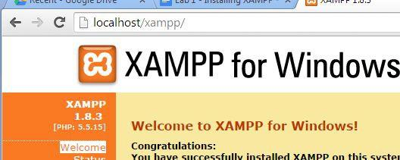

XAMPP FAQs

<https://www.apachefriends.org/faq_windows.html>